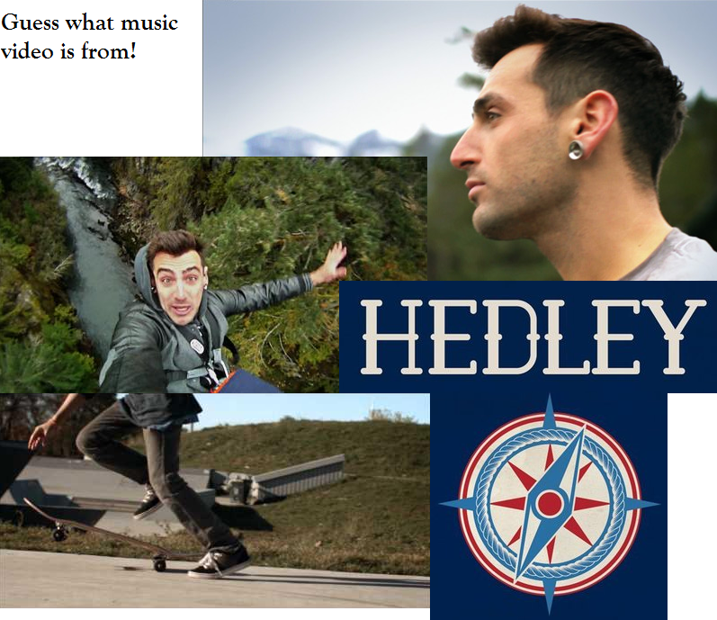

Oh (x2)
Oh woah, One life (x3)
One chance, two lips, free falling
We're about to lose our grip ___________
Five minutes too late
Can't be messing with fate
It's _____________ to get loud
Cause we've been up
When we should've been _____________
We've been down
When we could've been high
We'll come alive, _____________________
Woah!
It's a great __________ world, and you'll see
It could pass you by at light speed
You got one life, one life
Don't stop live it up
Woah!
If it's the last night in these streets
You'd be a ____________ to take a seat
You got one life, one life
Don't stop live it up
Oh, woah, One Life (x3)
Don't stop; don't stop live it up (x2)
Last thing you wanna make
Is your first mistake
But it's too _______________ now
So get up, get ready
Not everybody's ready
Not offence to you _________________
Cause we've been up when
When we should've been sleeping
We've been down
When we could've been high
We'll come alive, __________________
Woah!
14
13
12
11
10
9
8
6
7
5
4
3
2
1

It's a great big world, and you'll __________
It could pass you by at light speed
You got one life, one life
Don't stop live it up
Woah!
If it's the last night in these streets
You'd be a ___________ to take a seat
You got one life, one life
Don't stop live it up
Oh, woah, One Life x3
Don't stop; don't stop live it up
If you stop and think
You might start to ______________
You can't get it
If you don't keep giving
Can't get it if you don't
______________ giving
Oh!
It's a great big world, and you'll see
It could pass you by at light speed
You got one life, one life
Don't stop live it up
Woah!
If it's the last night in these streets
You'd be a ___________ to take a seat
You got one life, one life
Don't stop live it up
Oh woah, One Life (x3)
Don't stop; don't stop live it up
Oh woah, one life (x3)
Don't stop; don't stop live it up

Oh (x2)
Oh woah, One life (x3)
One chance, two lips, free falling
We're about to lose our grip now
Five minutes too late
Can't be messing with fate
It's time to get loud
Cause we've been up
When we should've been sleeping
We've been down
When we could've been high
We'll come alive, tonight
Woah!
It's a great big world, and you'll see
It could pass you by at light speed
You got one life, one life
Don't stop; don't stop live up
Woah!
If it's the last night in these streets
You'd be a fool to take a seat
You got one life, one life
Don't stop; don't stop live it up
Oh, woah, One Life (x3)
Don't stop; don't stop live it up (x2)
Last thing you wanna make
Is your first mistake
But it's too late now
So get up, get ready
Not everybody's ready
Not offence to you anyhow
Cause we've been up when
When we should've been sleeping
We've been down
When we could've been high
We'll come alive, tonight
Woah!

It's a great big world, and you'll see
It could pass you by at light speed
You got one life, one life
Don't stop; don't stop live up
Woah!
If it's the last night in these streets
You'd be a fool to take a seat
You got one life, one life
Don't stop; don't stop live it up
Oh, woah, One Life x3
Don't stop; don't stop live it up x2
If you stop and think
You might start to sink
You can't get it
If you don't keep giving
Can't get it if you don't
Keep giving
Oh!
It's a great big world, and you'll see
It could pass you by at light speed
You got one life, one life
Don't stop; don't stop live up
Woah!
If it's the last night in these streets
You'd be a fool to take a seat
You got one life, one life
Don't stop; don't stop live it up
Oh woah, One Life (x3)
Don't stop; don't stop live it up (x2)
Oh woah, one life (x3)
Don't stop; don't stop live it up (x2)

