Glass Trees Smoke Same Eyes Town City Keep Sons Falling Comes
People Brothers Lonely Cover Mountain Last Watching Flames Sky Dark Tonight Souls Remember End Night Ground Burn Father Night Together Skin

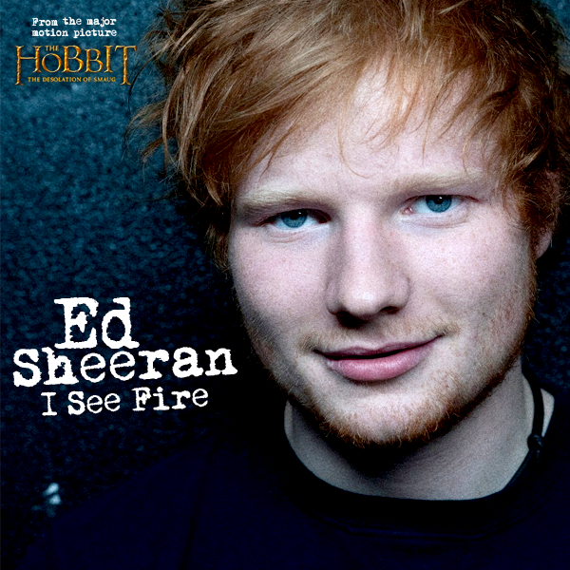
Oh, misty eye of the 1)…………………...below
2)…………..…… careful watch of my 3)…………….. souls
And should the 4)………….….be filled with fire and 5)…………………..
Keep 6)………………. over Durin's7)………………..
If this is to 8)……………..…. in fire
Then we should all 9)………….……. together
Watch the10) ………………… climb high into the 11)………………
Calling out 12)…………….…. oath, stand by and we will
Watch the 13)…………..… burn auburn on the 14)…………….……. side
And if we should die 15)…………………..
We should all die 16)………..………..
Raise a 17) ………………….. of wine for the 18)……………………... time
Calling out 19)…………..…….oath, prepare as we will
Watch the 20)……….…………… burn auburn on the 21)……………………………. side
Desolation 22)………………….……..upon the 23)……………………….…..
Now I see fire inside the mountain
I see fire burning the 24)………………..…….
And I see fire hollowing 25)……………..........
I see fire blood in the breeze
And I hope that you'll 26)……………..………me
Oh, should my 27)………………….….. fall
Then surely I'll do the 28)……………………..……
Confined in mountain halls we
Got too close to the flame
Calling out 29)……………... oath, hold fast and we will
Watch the 30)…………….… burn auburn on the 31)………………… side
Desolation 32)……………………….. upon the 33)……………….………
Now I see fire inside the mountain
I see fire burning the 34)………………………………
And I see fire hollowing 35)……………..………….
I see fire blood in the breeze
And I hope that you'll 36)…………….………….me
And if the 37)……………….…… is burning
I will 38)………………….….. my 39) …………………..
For if the 40)…………………….……returns
Then my 41)………………………….…. will die
And as the sky's 42)……………..……….. down
Crashed into this 43)……………………….…… 44) ………………
With that shadow upon the 45)……………………
I hear my 46)………………………. screaming out!
Now I see fire inside the mountain
I see fire burning the 47)………………..…………
And I see fire hollowing 48)………………..……….
I see fire blood in the breeze
I see fire (oh, you know I saw a 49)………………. burning)
And I see fire (feel the heat upon my 50)…………………….………)
I see fire
Fire
I see fire burn auburn on the 51)………………….………... side.

