I tried playing it cool
Girl when I'm looking at you
I can't ever be brave
Cause you make my _____________ race
Shot me out of the _____________
You're my kryptonite
You keep making me weak
Yeah, ___________________ and can't breathe
Some things gotta give ______________
Cause I'm dying just to make you see
That I need you here with me now
Cause you've got that ____________ thing
So get out, get out, get out of my head
And fall into my arms instead
I don't, I don't, don't know what it is
But I need that one thing
And you've got that one thing
Now I'm climbing the ________________
But you don't notice at all
That I'm going out of my mind
All day and all _________________
Some things gotta give now
Cause I'm dying just to know your _____________
And I need you here with me now
_______________ you've got that one thing
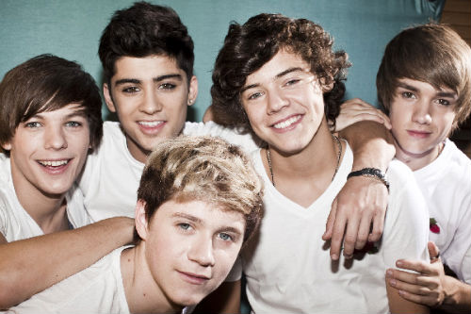

So get out, get out, get out of my head
And fall into my arms instead
I don't, I don't, don't ______________ what it is
But I need that one thing
And you've got that one thing
So get out, get out, get out of my mind
And come on, come into my life
I don't, I don't, don't know _______________ it is
But I need that one thing
And you've got that one thing
You've got that one thing
Get out, get out, get out of my _______________
And fall into my arms instead
So get out, get out, get out of my head
And fall into my arms instead
I don't, I don't, don't know what it is
But I need that _____________ thing
And you've got that one thing
Get out, get out, get out of my mind
And come on, come into my life
I don't, I don't, don't know what it is
But I ________________ that one thing
And you've got that one thing

